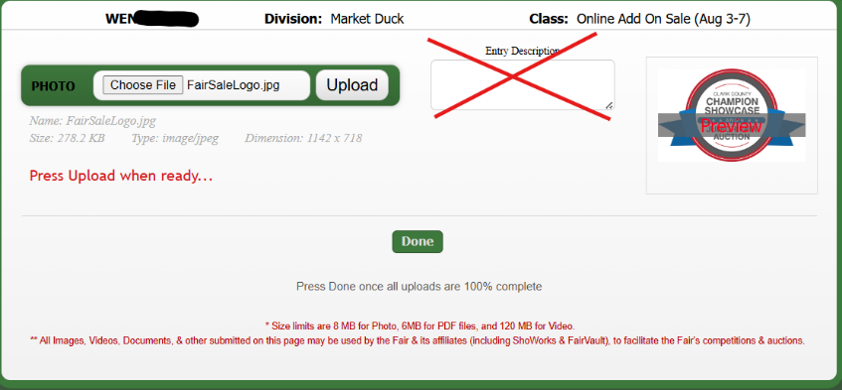
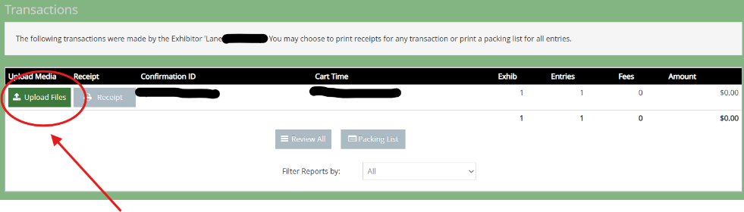
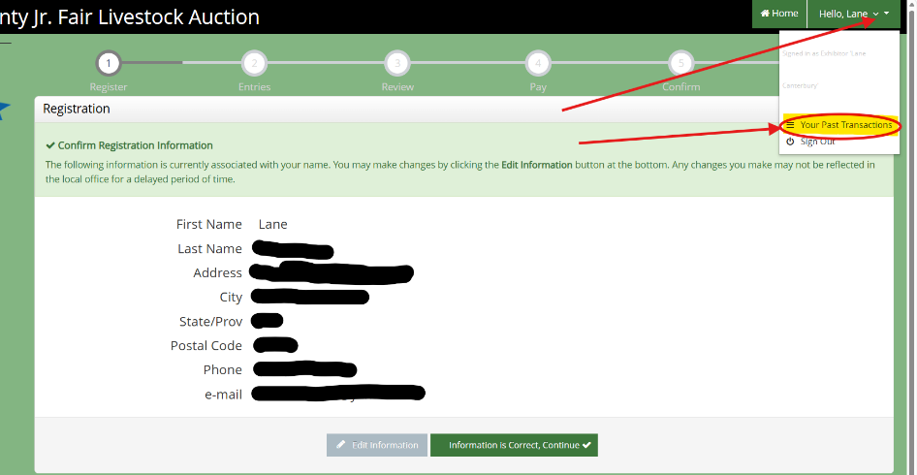
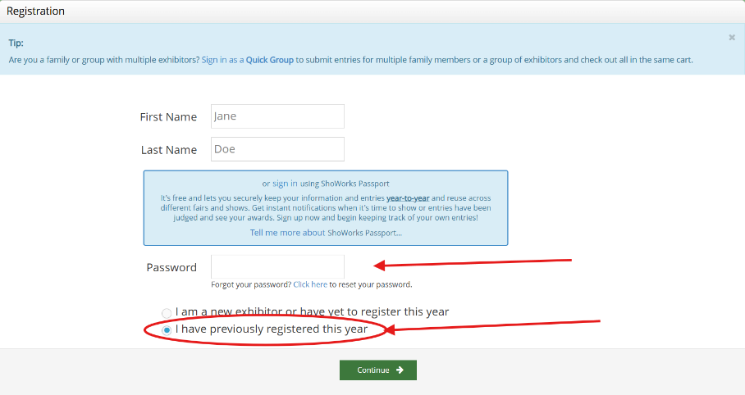

Click on the name in the upper right hand corner and select view past transactions from the drop-down menu
- Select choose file
- Press upload when ready
- Once Upload is complete press Done
Select Upload Files
Sign In using the password you set when you registered for the auction.
Select I have previously registered this year
Exhibitor Sign In
Photo Upload Instructions

